Role: Admin

URL: <http://dev.92agents.com/agentadmin>

Device : HP Laptop, 8.00 GB RAM, 64-bit operating system, x64-based processor

OS: Windows 10 Pro, Version : 22H2

Browser: Chrome 108

**Issue List:**

***Issue Type: UI***

***Severity : Low***

1. Login to Admin Panel.
2. On the Dashboard page, click on More Info appearing on the Total Sellers/Buyers section.
3. Observe the Sort Icons on the Column headers

Actual: The sort icons appear to be cropped on column headers.

Expected: The sort icons on column headers should appear properly.

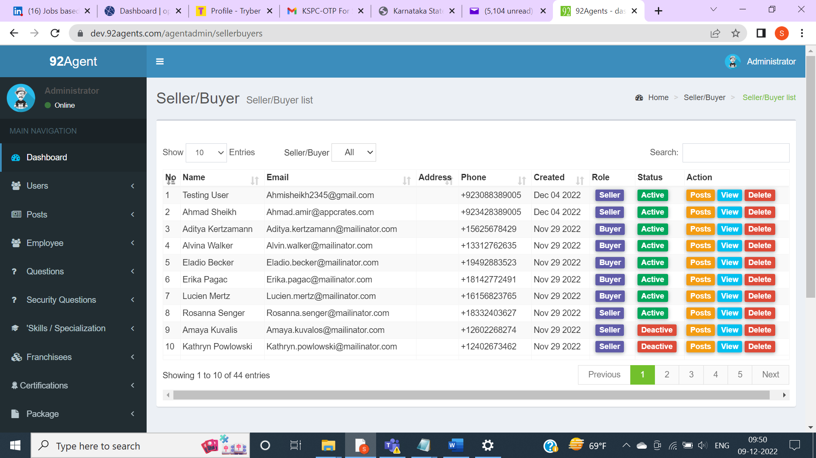

***Issue Type: Functional***

***Severity : Medium***

1. Login to Admin Panel.
2. On the Dashboard page, click on More Info appearing in the Total Sellers/Buyers section.
3. Search for ‘yopmail’.
4. Matching records appear.
5. Click on ‘View’ appearing for ‘ [Smitha902@yopmail.com](mailto:Smitha902@yopmail.com)’.
6. Buyer Profile page appears.
7. Click on ‘Send Reset Link.

Actual: Click here text appears as Plain text though the text is hyperlinked.

Expected: Click here should be displayed in blue color as the text is a hyperlink

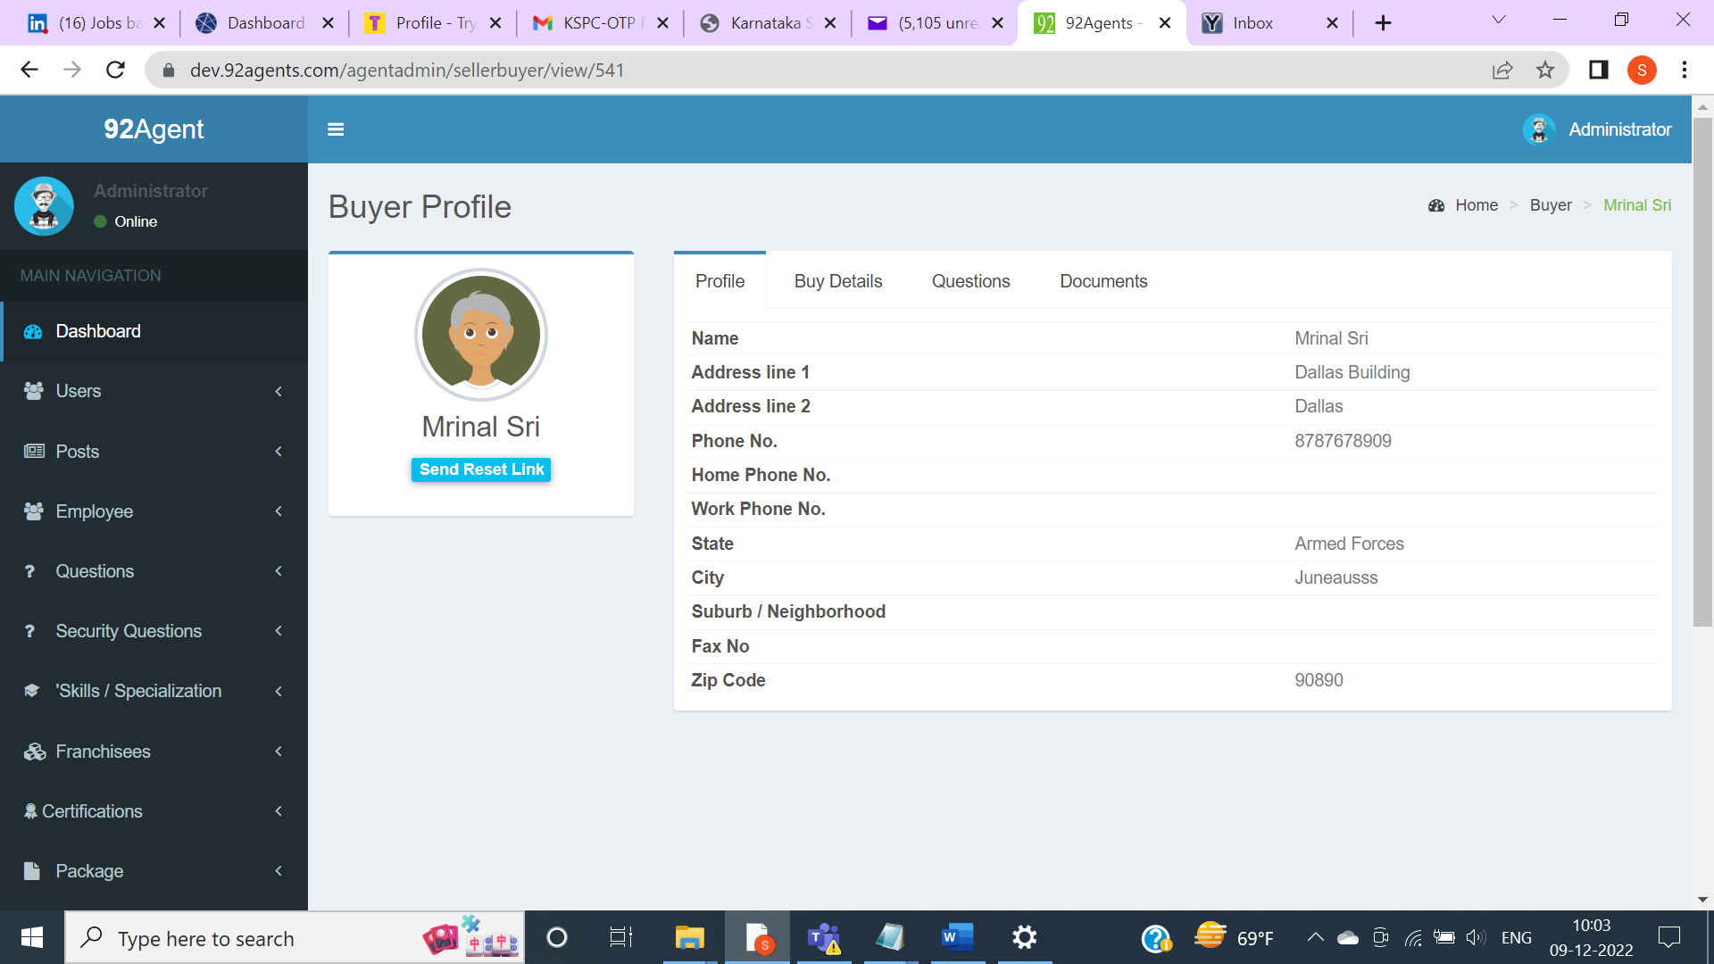

Clicking on ‘Send Reset Link’

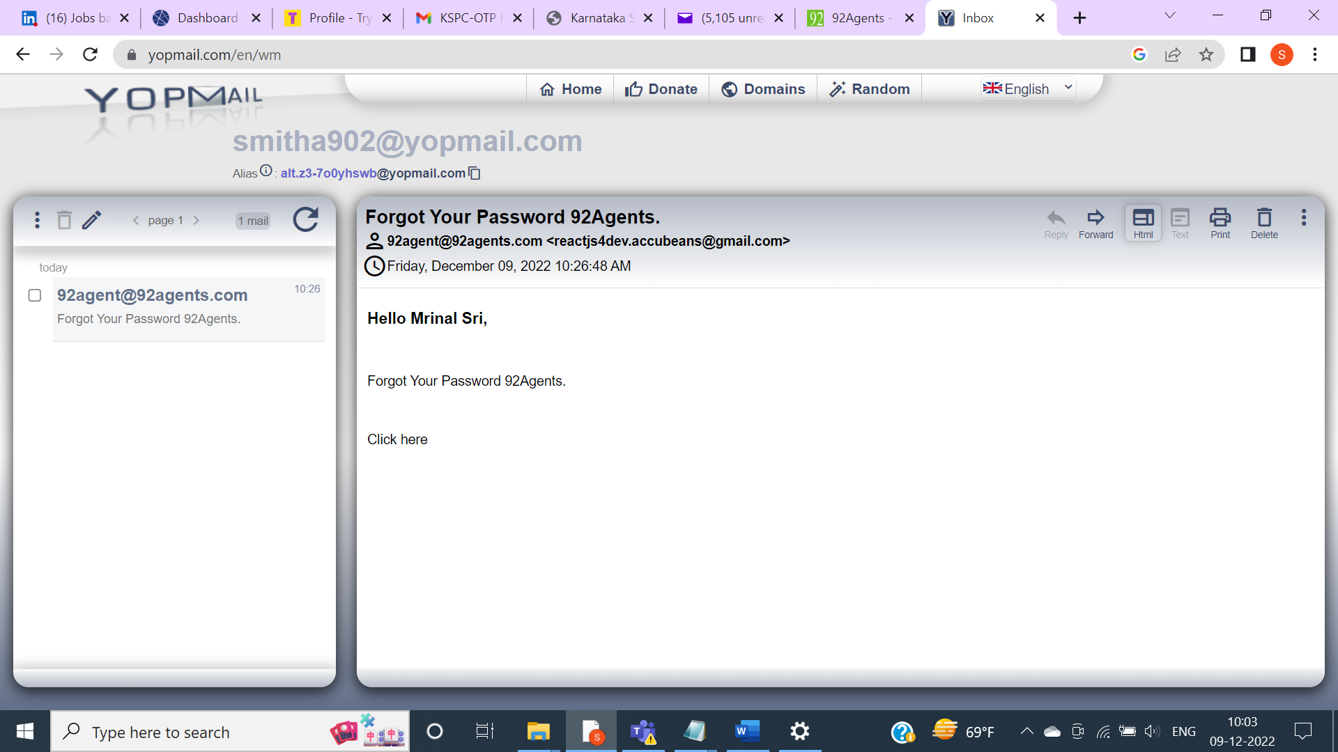

***Issue Type: UX***

***Severity : Medium***

1. Login to Admin Panel.
2. On the Dashboard page, click on More Info appearing in the Total Sellers/Buyers section.
3. Search for ‘yopmail’.
4. Matching records appear.
5. Click on Home in the breadcrumb.
6. On the Dashboard page, click on More Info appearing in the Total Sellers/Buyers section.

Actual: Previously entered Search criteria ‘yopmail’ is still retained and matching records specific to the search specified are appearing. Also, the ‘All’ is appearing as the default value for Seller/Buyer though the Search is done with Buyer ( repeating the above steps).

Expected: Search criteria should not be displayed and the default page with all records should be displayed.

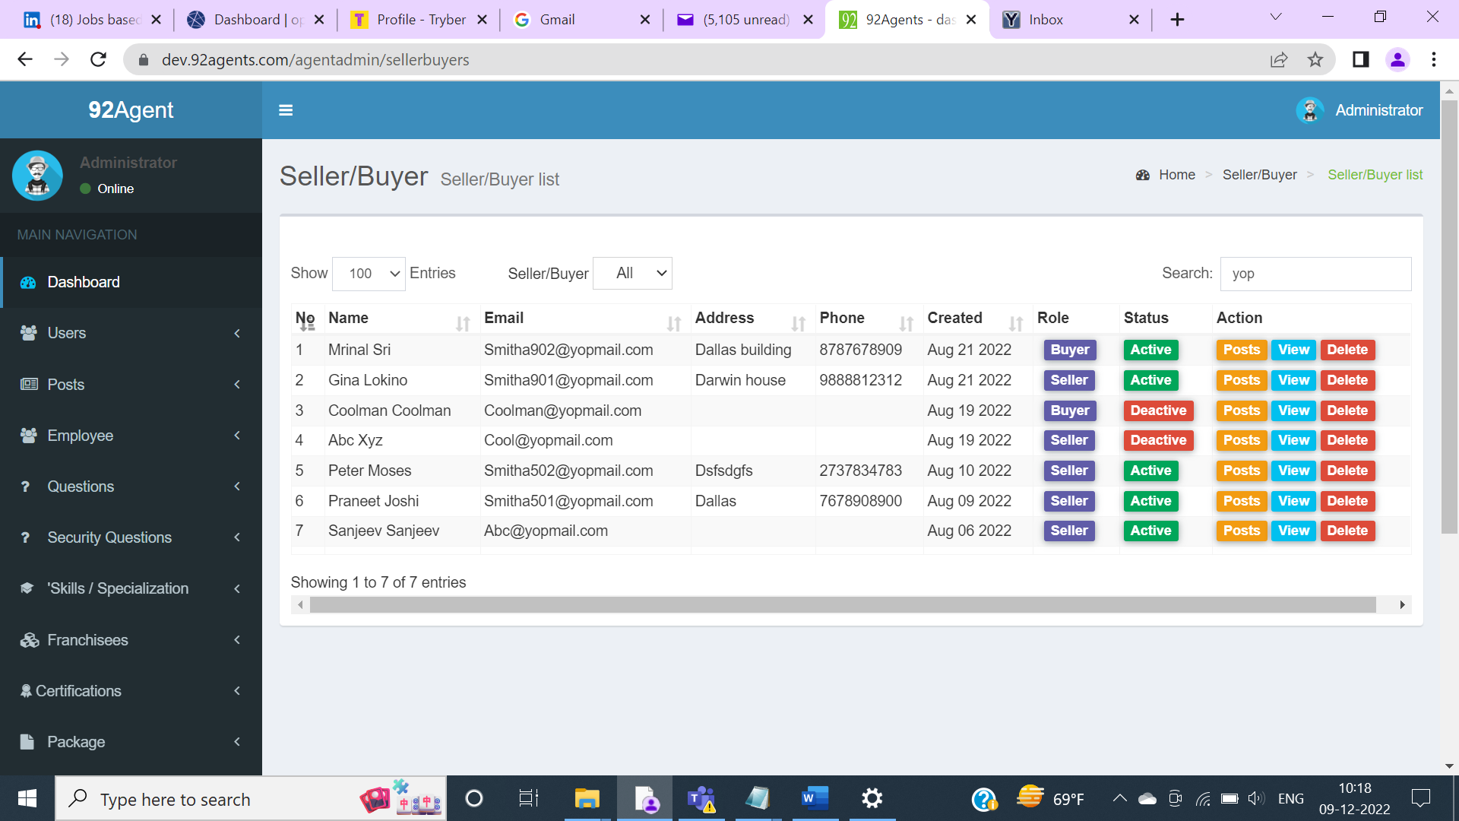

***Issue Type: UX***

***Severity : Medium***

1. Login to Admin Panel.
2. On the Dashboard page, click on More Info appearing in the Total Sellers/Buyers section.
3. Search for ‘yopmail’.
4. Matching records appear.
5. Click on ‘Activate’ or ‘Deactivate’ appearing on the Status column header.

Actual: Popup header appears as ‘Delete Confirmation’ when Activate/Deactivate action is performed for the user. The same popup header appears when clicking on the Delete action for the user.

Expected: Popup header should appear as Activate Conformation/ Deactivate Confirmation when Activate/Deactivate action is performed for the user.

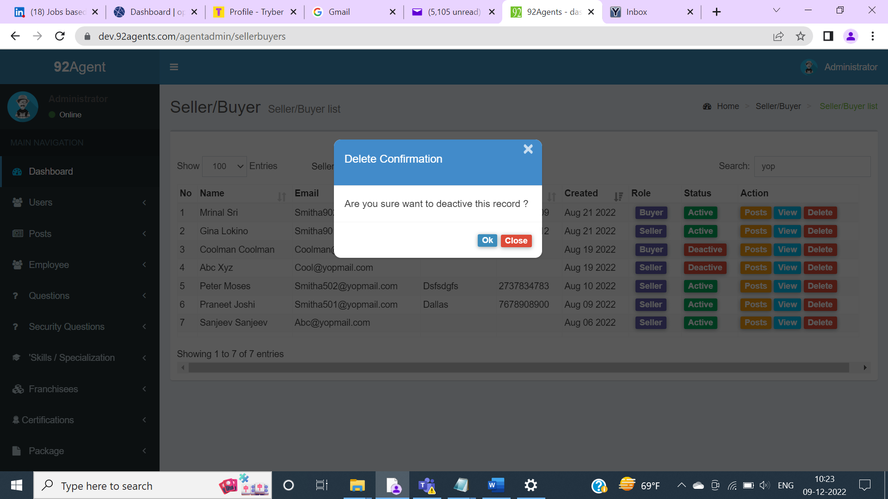

***Issue Type: UI***

***Severity : Medium***

1. Login to Admin Panel.
2. On the Dashboard page, click on More Info appearing in the Total Agents section.
3. Observe the issue on the Agent List page.

Actual: The drop-down value for Verification is not inline.

Expected: The drop-down values should be in line with the Verification label.

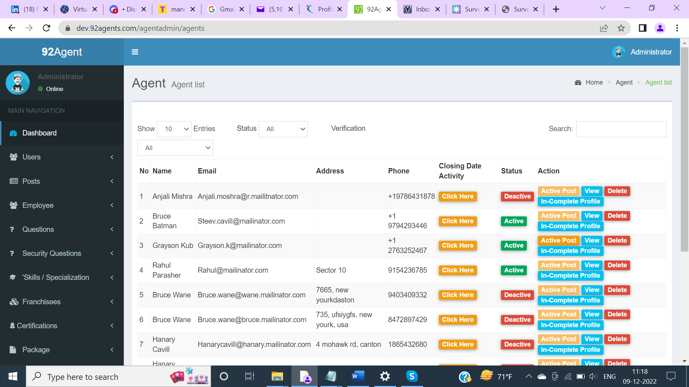

***Issue Type: Functional***

***Severity : Medium***

1. Login to Admin Panel.
2. On the Dashboard page, click on More Info appearing in the Total Agents section.
3. Filter the records by specifying the search criteria as ‘yopmail’.
4. Matching records appear.
5. Click on Closing Date Activity ( Email: [Smitha903@yopmail.com](mailto:Smitha903@yopmail.com)) and observe the issue.

Actual: Getting array exception when clicking on Closing Date activity.

Expected: Exception should not be displayed.

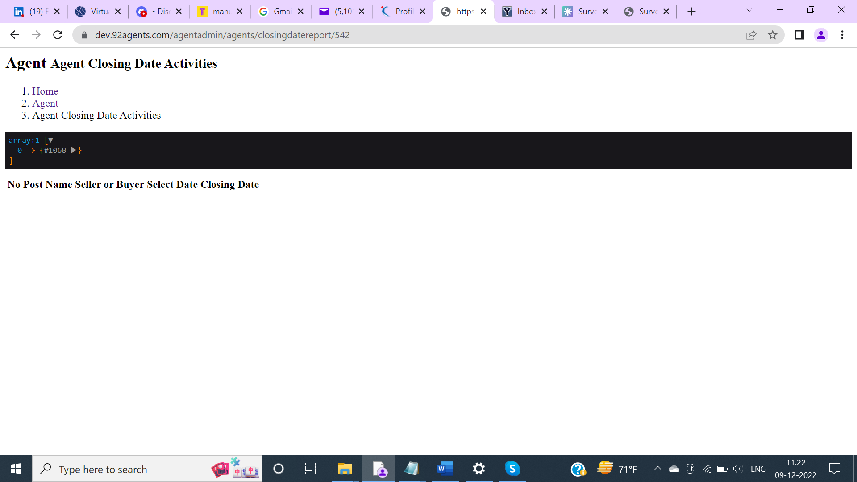

***Issue Type: Functional***

***Severity : Medium***

1. Login to Admin Panel.
2. On the Dashboard page, click on More Info appearing in the Total Agents section.
3. Filter the records by specifying the search criteria as ‘yopmail’.
4. Matching records appear.
5. Click on In-Complete Profile ( Email: [Smitha903@yopmail.com](mailto:Smitha903@yopmail.com)) and observe the issue.

Actual: No action is triggered when clicking on In-Complete Profile.

Expected: Page specific to Profile completion should be displayed.

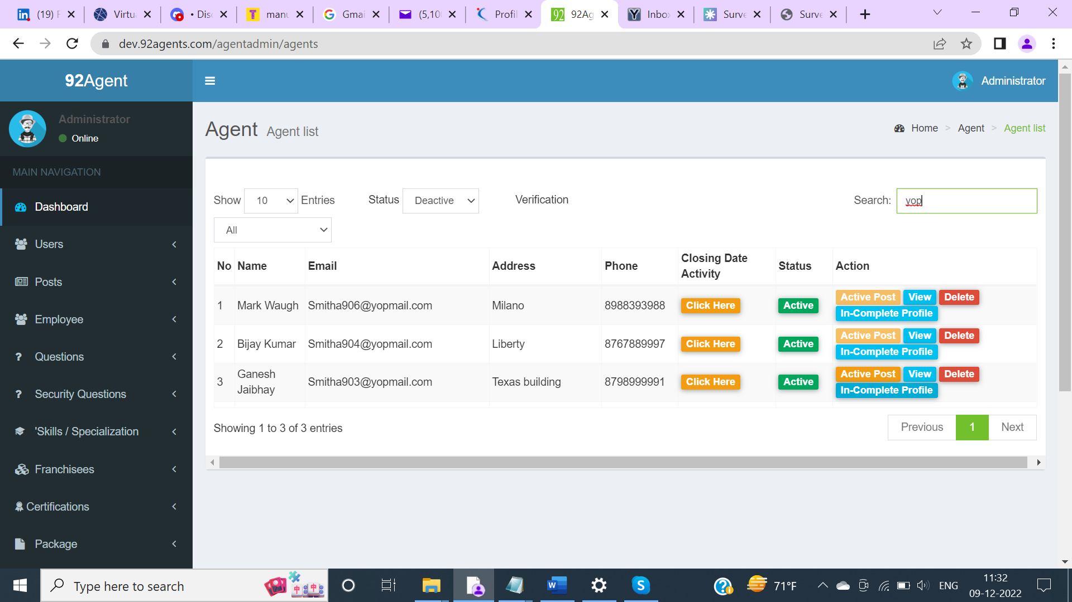

***Issue Type: Functional***

***Severity : Medium***

1. Login to Admin Panel.
2. On the Dashboard page, click on More Info appearing in the Total Agents section.
3. Filter the records with Status as ‘Active/ Deactive’.

Actual: Records are not getting filtered when the filter is applied for Status.

Expected: Records should be filtered based on Status.

Note: Same issue exists for Verification filter as well.

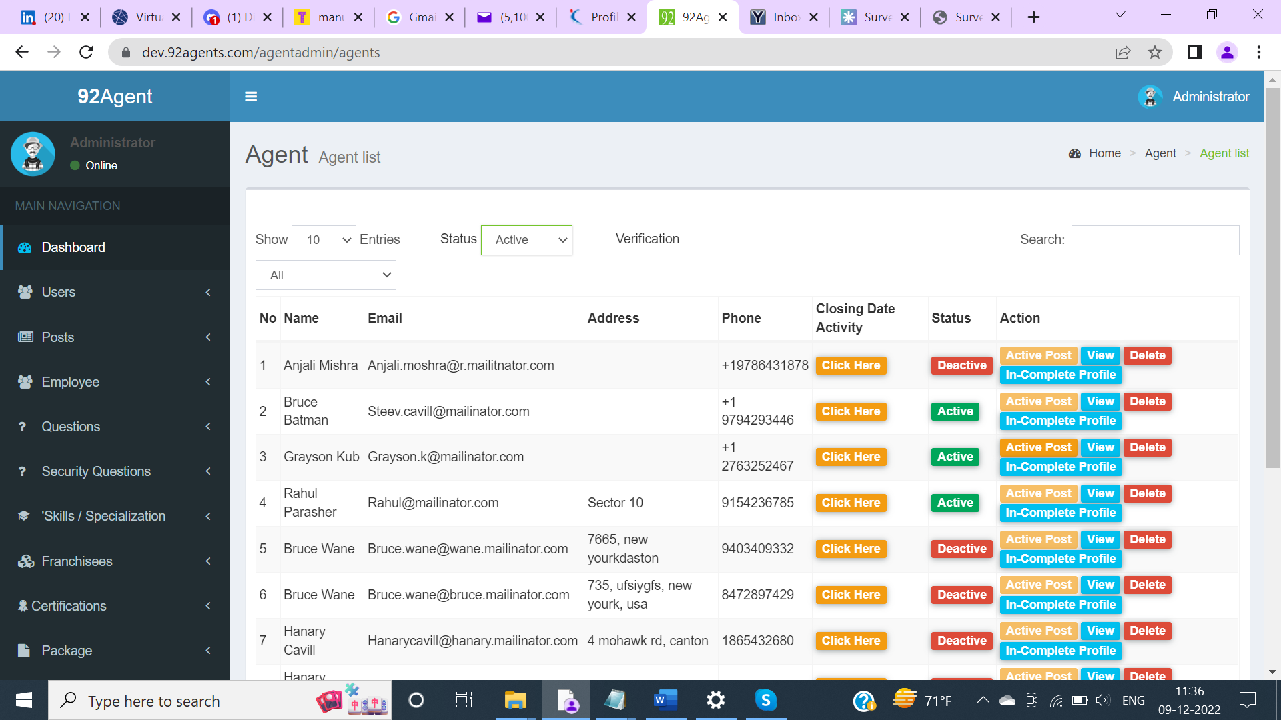

***Issue Type: Functional***

***Severity : Medium***

1. Login to Admin Panel.
2. On the Dashboard page, click on More Info appearing in the Total Post.
3. Enter any Search criteria in Search field.

Actual: Search is not functioning.

Expected: Search should be functioning and matching records should appear else No results when there are no matching records.

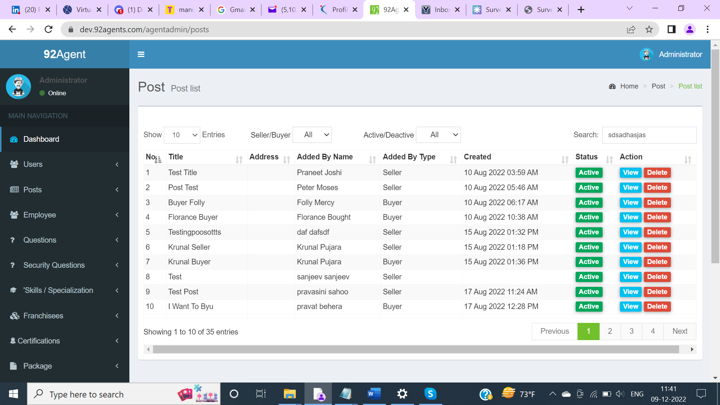

***Issue Type: Functional***

***Severity : High***

1. Login to Admin Panel.
2. On the Dashboard page, click on More Info appearing in the Total Post.
3. Click on View appearing for any of the Post

Actual: Error message appears.

Expected: Post should be displayed.

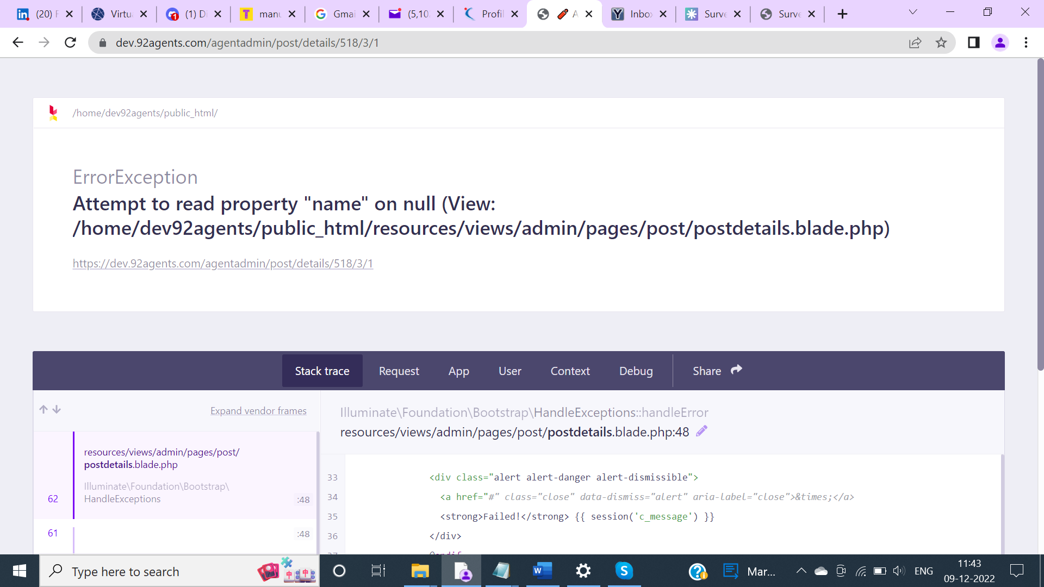

***Issue Type: Usability***

***Severity : Low***

1. Login to Admin Panel.
2. On the Dashboard page, click on More Info appearing in the Total Questions.

Actual: Button label appears as Add Question.

Expected: The button label should appear as Add Questions as we can add multiple questions on the same form after saving.

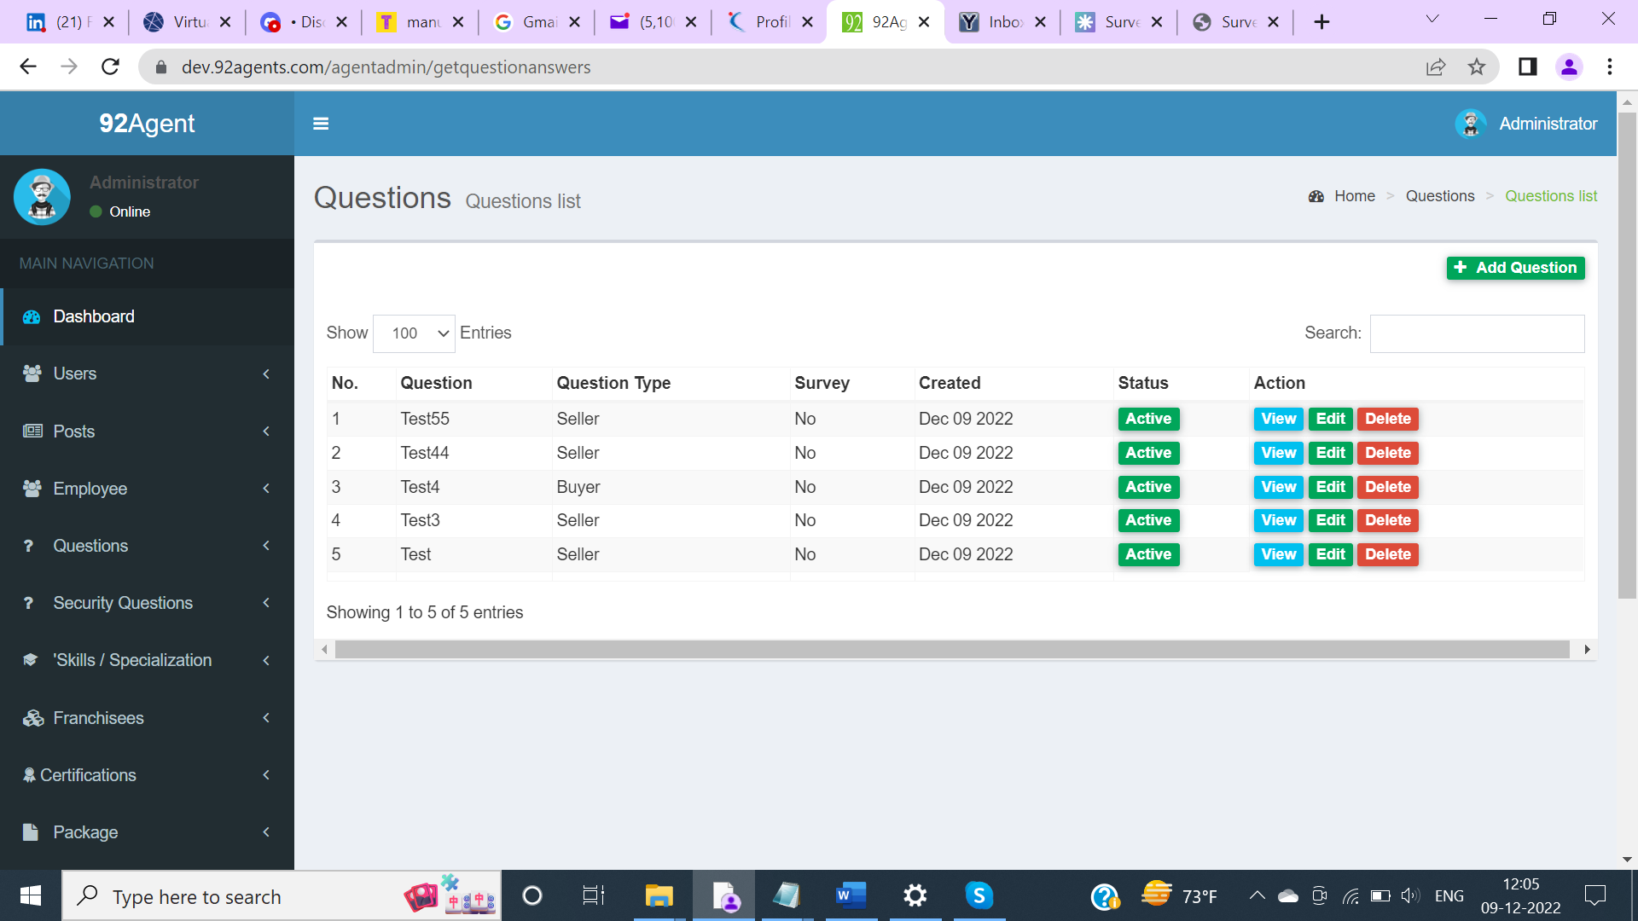

***Issue Type: Functional***

***Severity : Low***

1. Login to Admin Panel.
2. On the Dashboard page, click on More Info appearing in the Total Questions.
3. Click on View appearing for the question.

Actual: Predefined value appears in Answer though No answer is provided.

Expected: The answer should be blank.

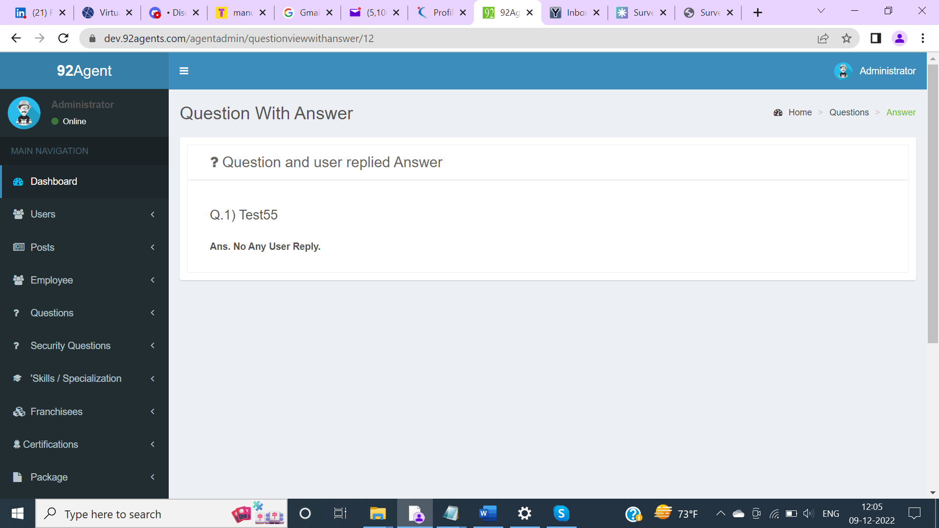

***Issue Type: UI***

***Severity : Low***

1. Login to Admin Panel.
2. On the Dashboard page, click on More Info appearing in the Total Questions.
3. Click on Edit appearing for the question.

Actual: Header appears as Edit Questions.

Expected: The header should appear as Edit Question as we can only Edit one Question.

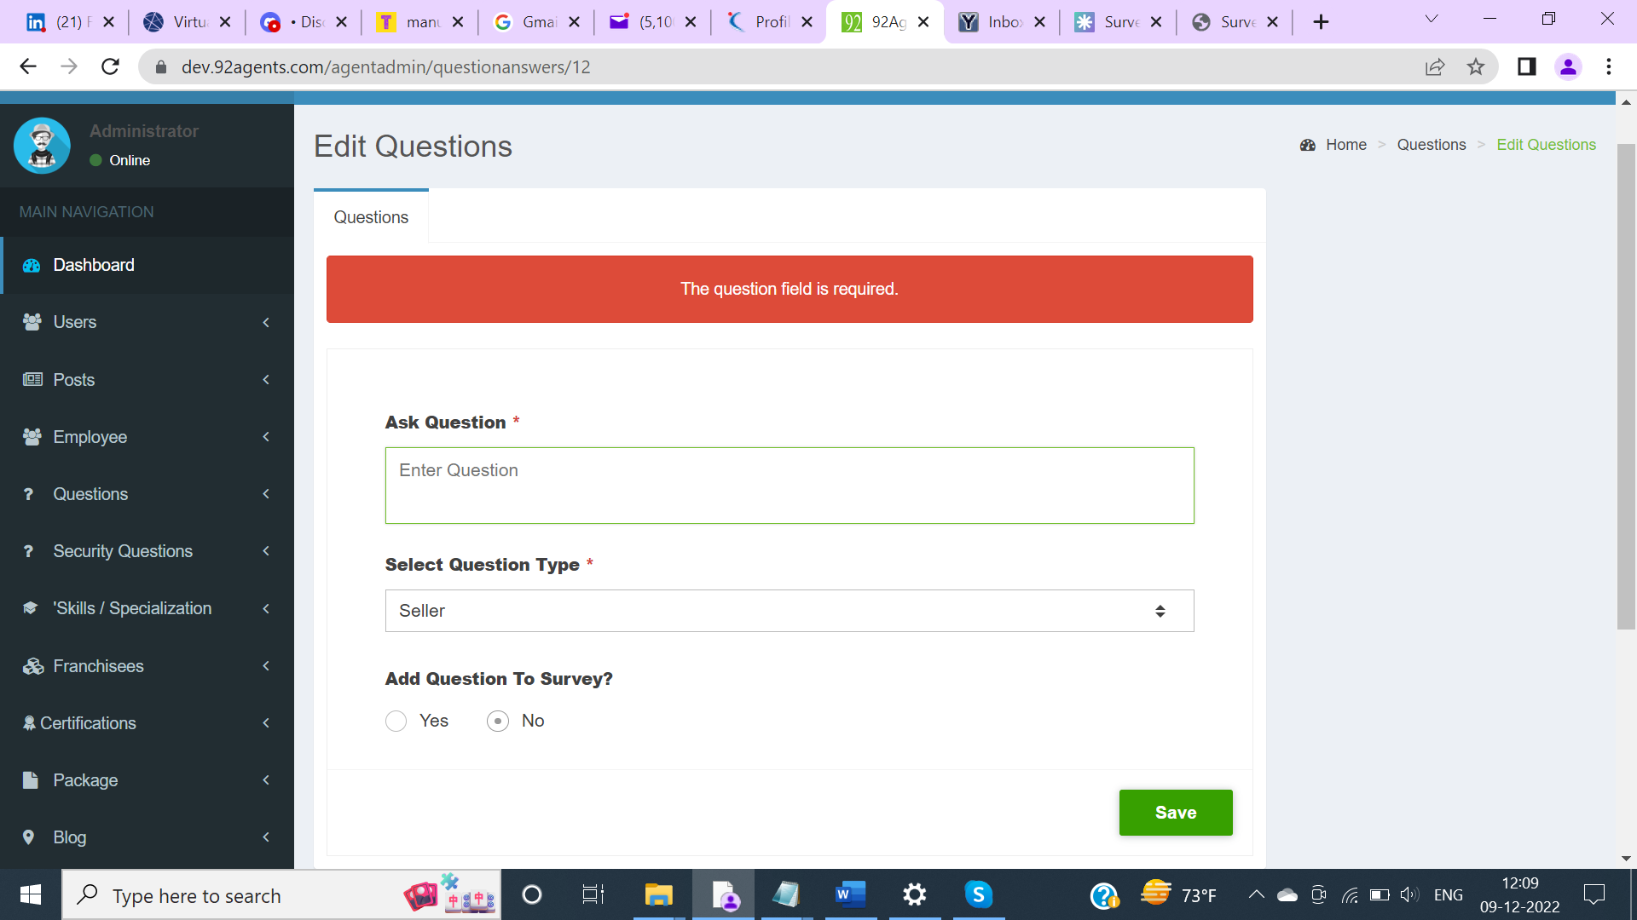

***Issue Type: Functional***

***Severity : Major***

1. Login to Admin Panel.
2. On the Dashboard page, click on More Info appearing in the Total Questions.
3. Click on Edit appearing for the question.

Actual: There is no Cancel action control to go back to the Questions List page.

Expected: Cancel action control should be displayed for the User to go back to the Questions list page.

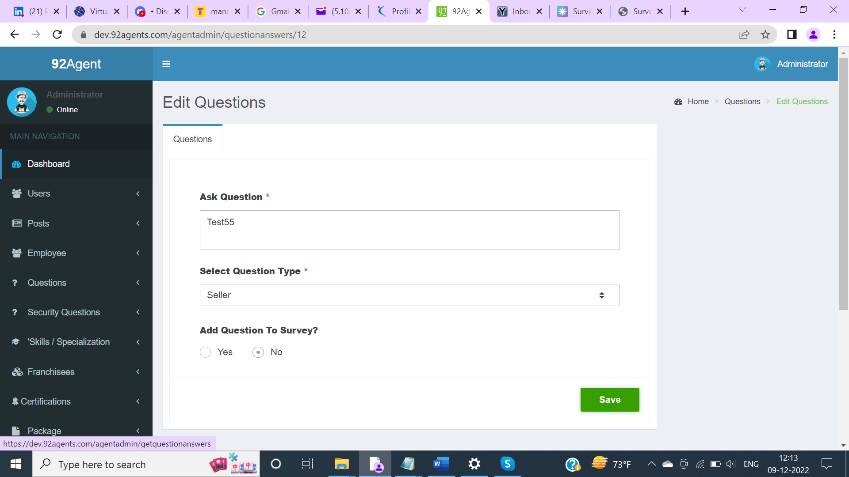

***Issue Type: Functional***

***Severity : Major***

1. Login to Admin Panel.
2. On the Dashboard page, click on More Info appearing in the Total Questions.

Actual: There is no Sorting icons for the values to be sorted on Column headers on the Questions List page.

Expected: Sorting should be provided on column headers and should be in sync with other pages where sorting is displayed for column headers ( Posts, Agents, etc.. pages).

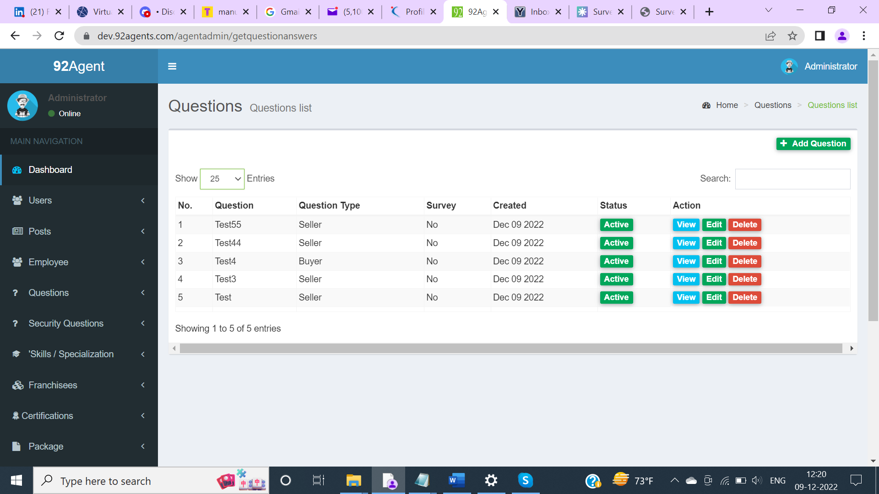

***Issue Type: Functional***

***Severity : Major***

1. Login to Admin Panel.
2. On the Dashboard page, click on More Info appearing in the Total Security Questions.
3. Click on Add Security Question.
4. Add the ‘What Is Your Date Of Birth And Place Of Birth?’ question ( existing question).
5. Click on Submit.

Actual: Getting exception when trying to add a duplicate Security question.

Expected: A validation message should appear when a duplicate security question is added.

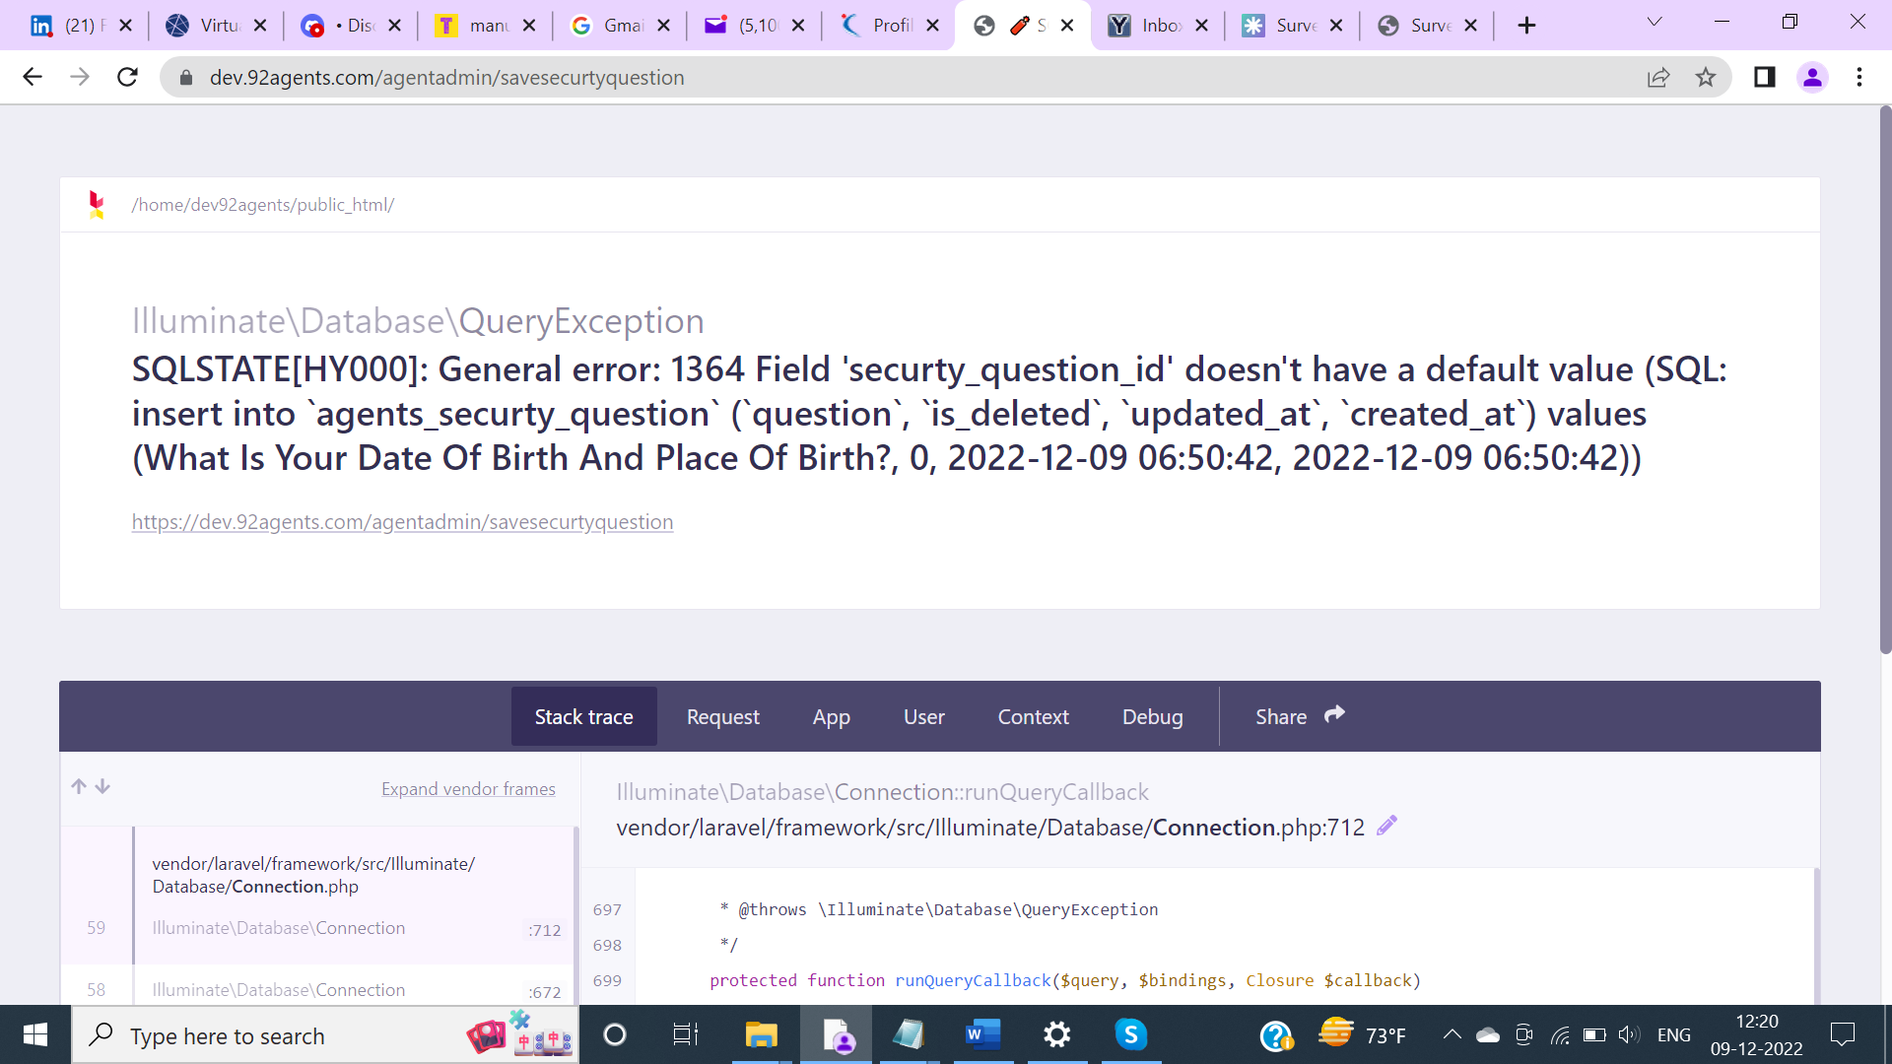

***Issue Type: UI***

***Severity : Minor***

1. Login to Admin Panel.
2. On the Dashboard page, click on More Info appearing in the Total Security Questions.
3. Click on Edit Security Question.
4. Click on Submit.

Actual: ‘security question has been updated successfully’ message appears.

Expected: ‘Security Question has been updated successfully’ should appear with the proper case in the message displayed.

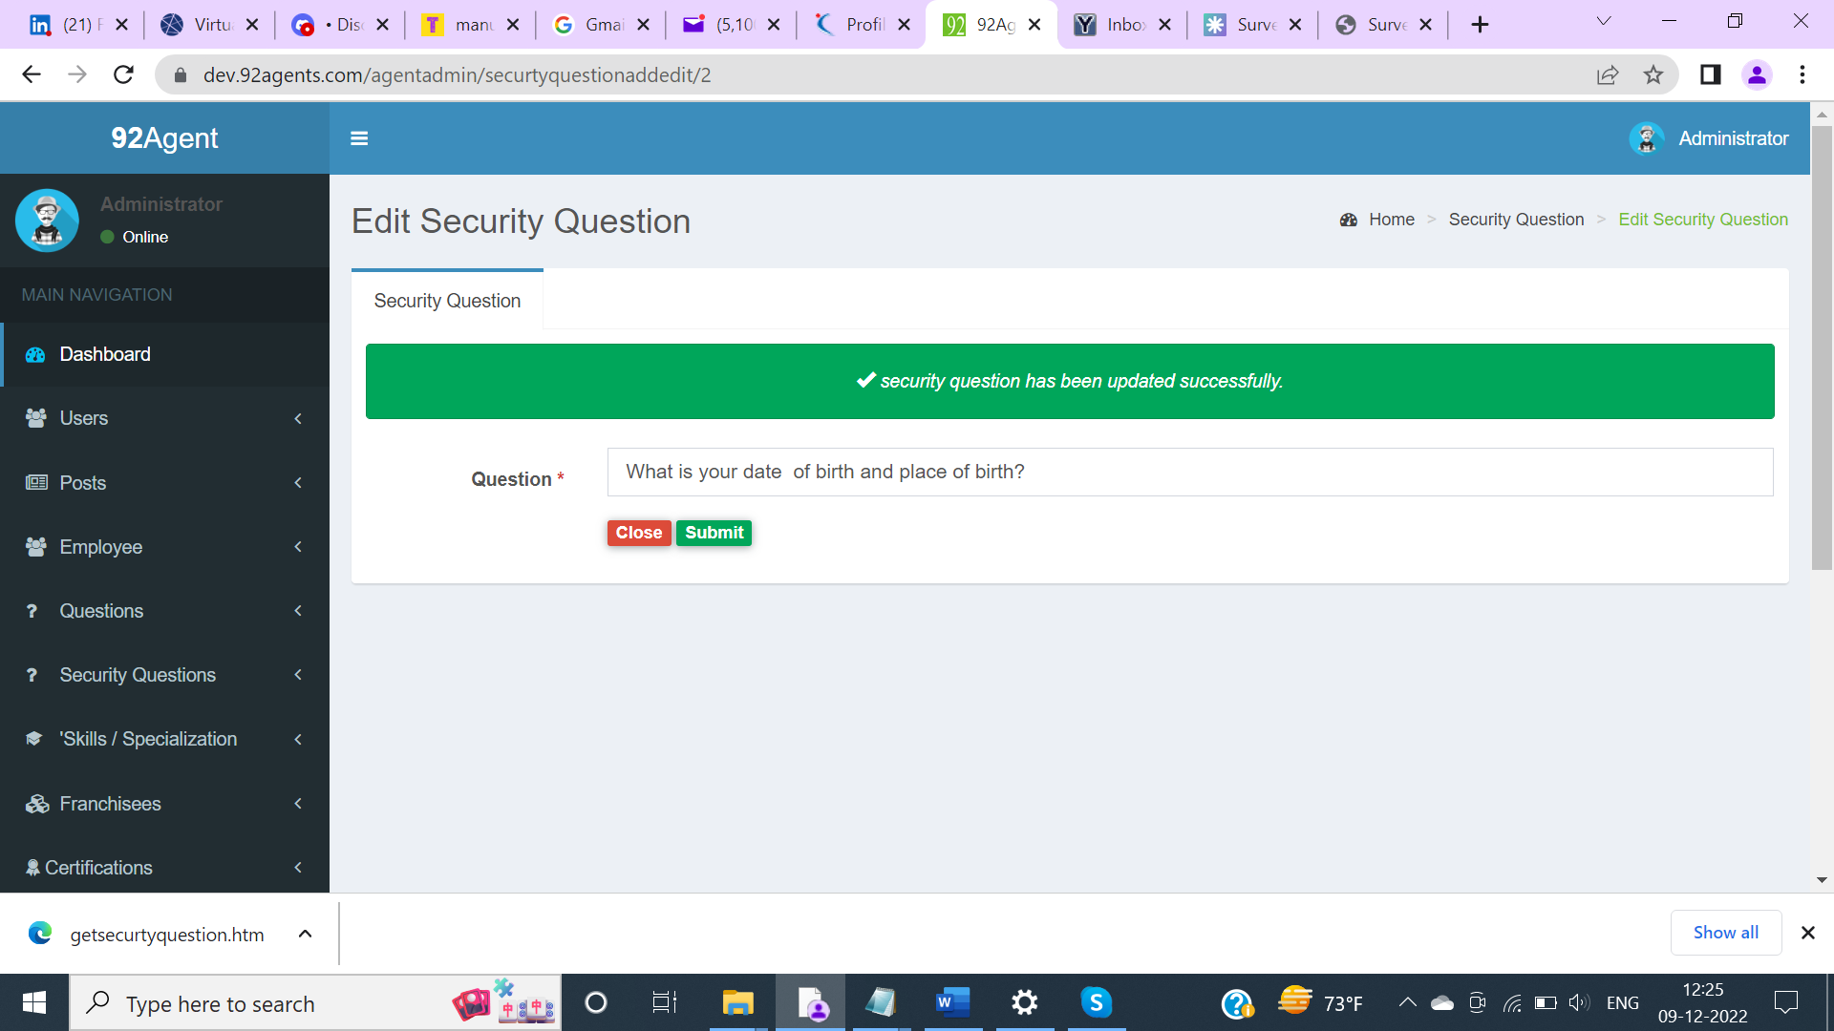

***Issue Type: Functional***

***Severity : Major***

1. Login to Admin Panel.
2. On the Dashboard page, click on More Info appearing in the Total Security Questions.

Actual: There is no Sorting icons for the values to be sorted on Column headers on the Security Questions List page.

Expected: Sorting should be provided on column headers and should be in sync with other pages where sorting is displayed for column headers ( Posts, Agents, etc.. pages).

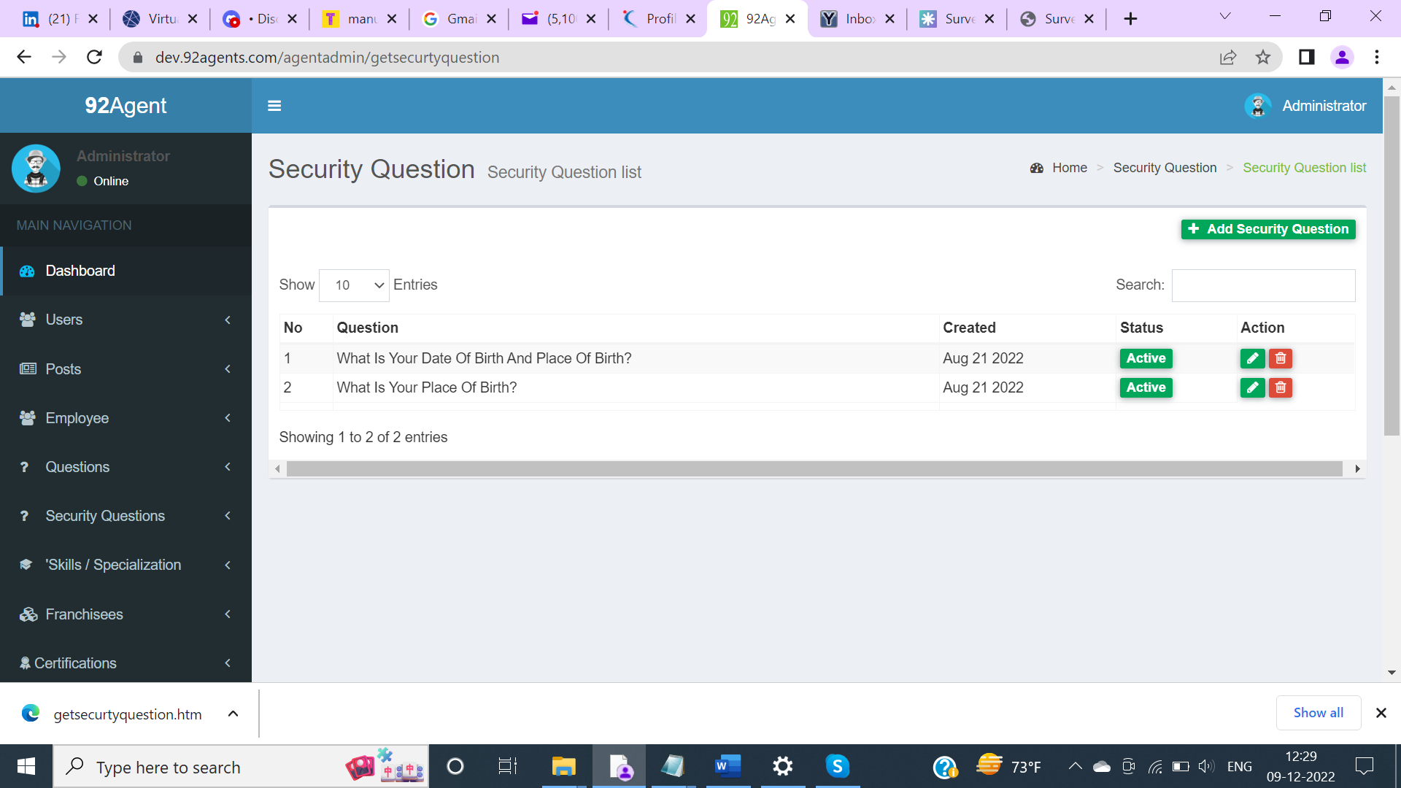

***Issue Type: Functional***

***Severity : Major***

1. Login to Admin Panel.
2. On the Dashboard page, click on More Info appearing in the Total Security Questions.
3. Delete a Security question.
4. Add same Security question which was deleted.

Actual: Getting validation message that the Question has been already taken.

Expected: User should be able to add same Security question which was deleted.

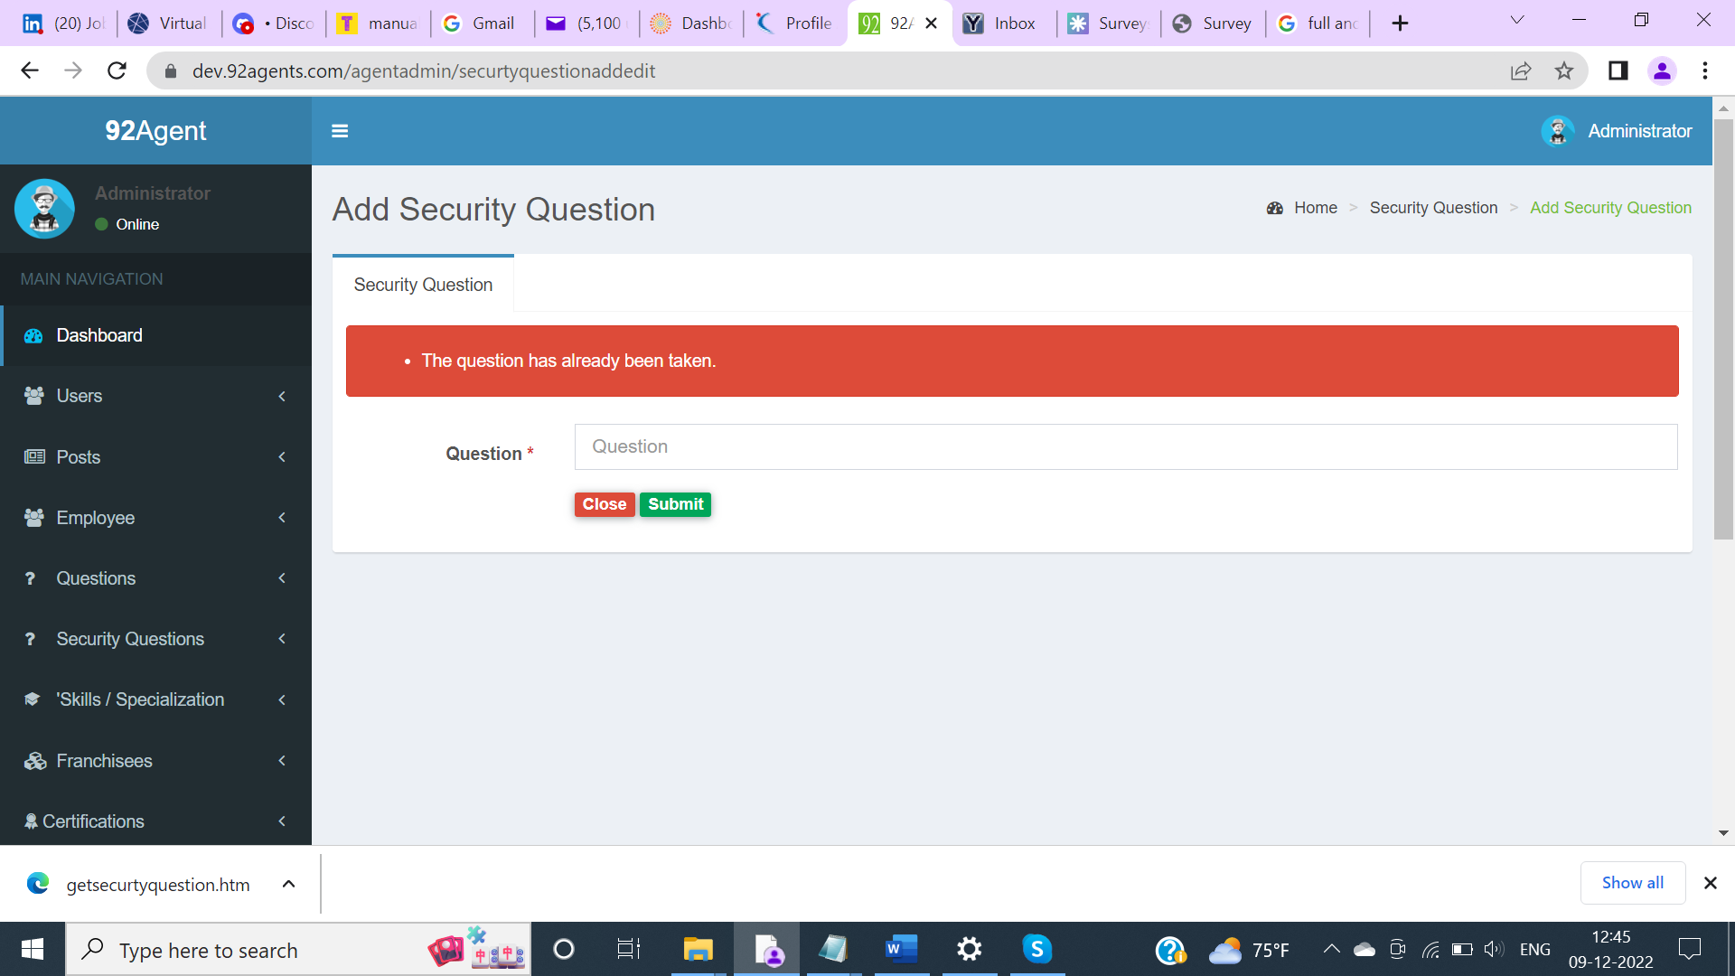

***Issue Type: Functional***

***Severity : Major***

1. Login to Admin Panel.
2. On the Dashboard page, click on More Info appearing in the Total Certifications.
3. Try to add duplicate Certifications or add new certifications.

Actual: Exception occurs when trying to add duplicate certifications or add new certifications.

Expected: A validation message should appear when trying to add duplicate certification and user should be able to add new certifications successfully.

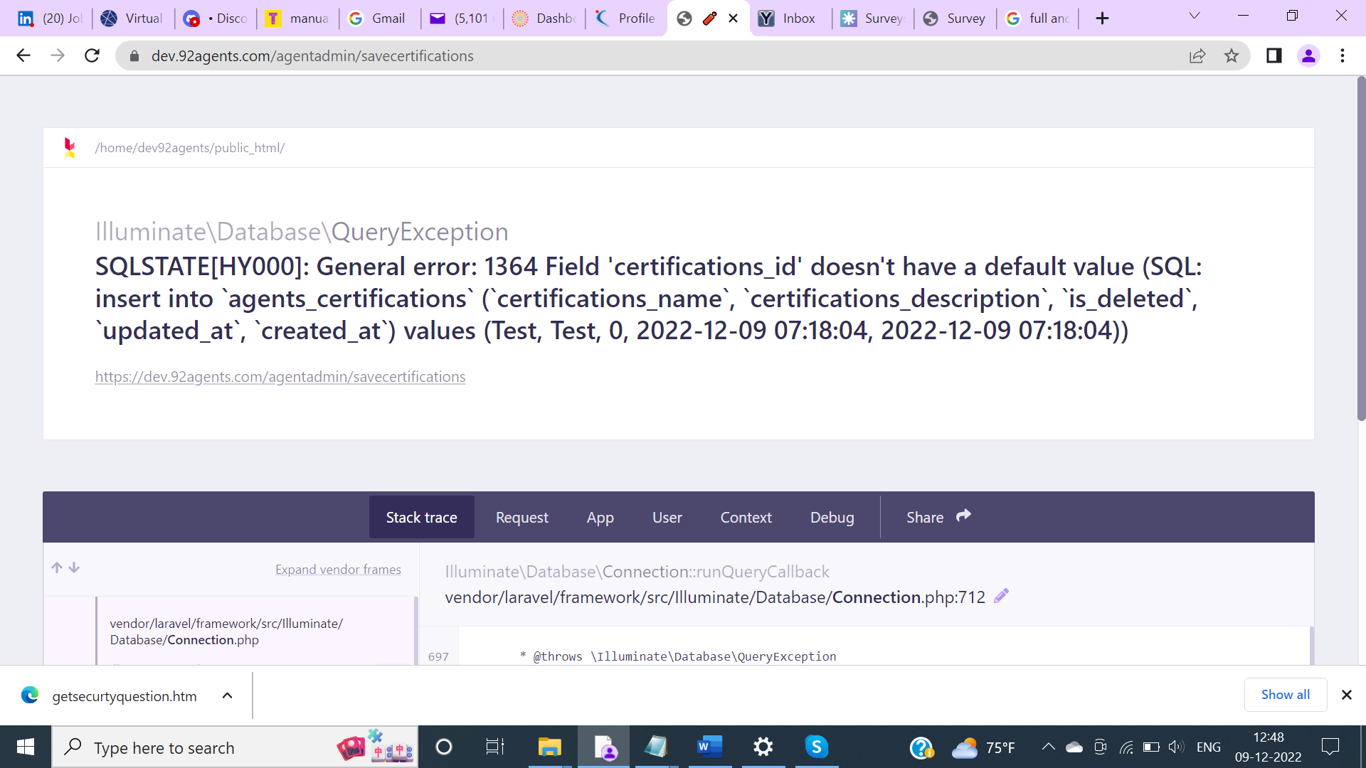

***Issue Type: Functional***

***Severity : Major***

1. Login to Admin Panel.
2. On the Dashboard page, click on More Info appearing in the Total Franchise.
3. Try to add new Franchise.

Actual: Exception occurs when trying to add a new Franchise.

Expected: The user should be able to add new Franchise successfully.

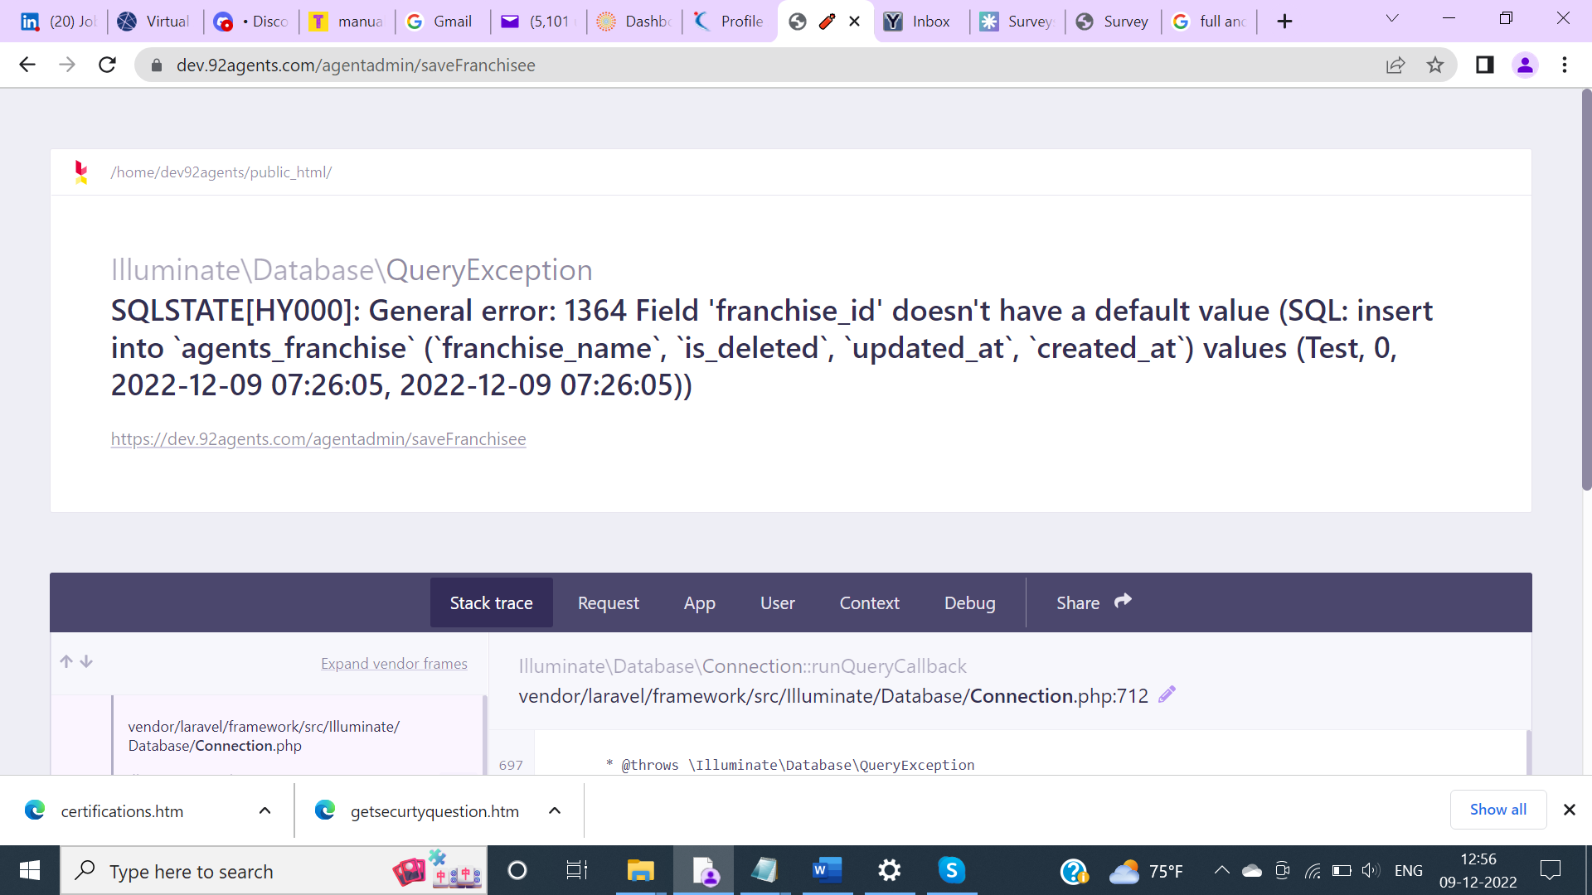

***Issue Type: Functional***

***Severity : Major***

1. Login to Admin Panel.
2. On the Dashboard page, click on More Info appearing in the Total Area.
3. Try to add new Area.

Actual: Exception occurs when trying to add a new Area.

Expected: The user should be able to add new Area successfully.

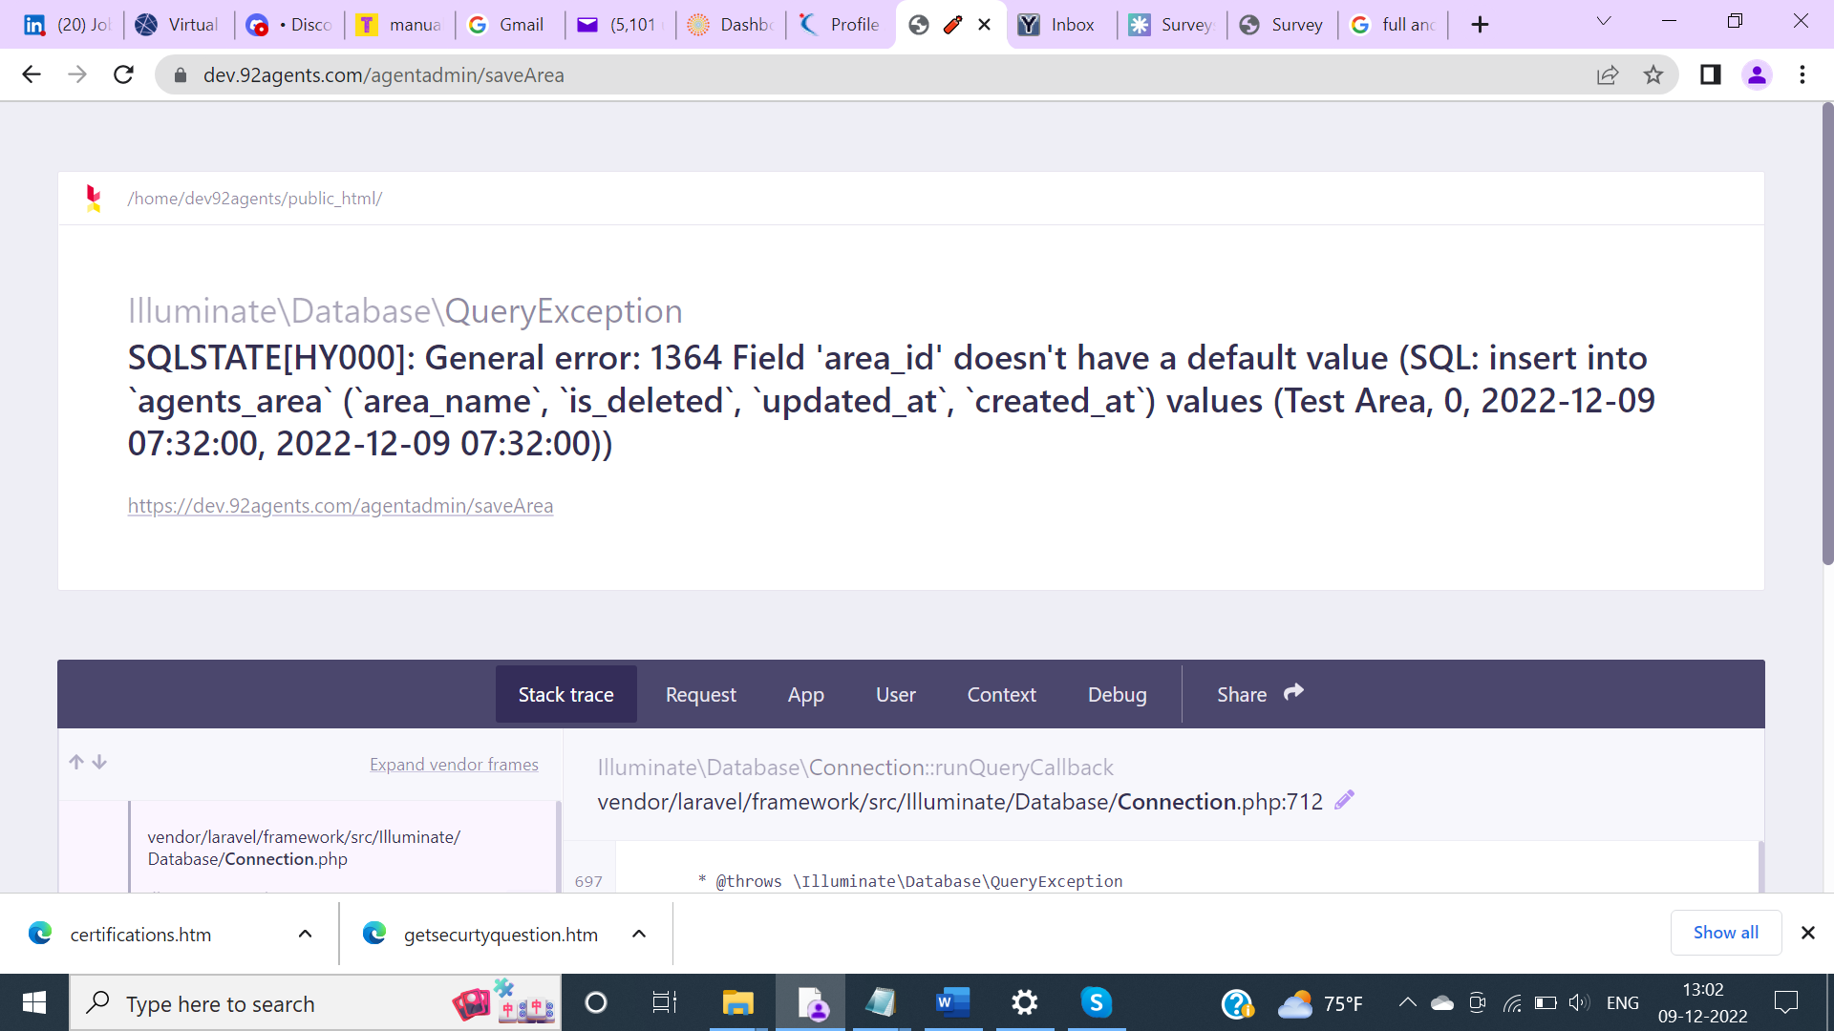

***Issue Type: Functional***

***Severity : Major***

1. Login to Admin Panel.
2. On the Dashboard page, click on More Info appearing in the Total City.
3. Try to add new City.

Actual: Exception occurs when trying to add a new City.

Expected: The user should be able to add new City successfully.

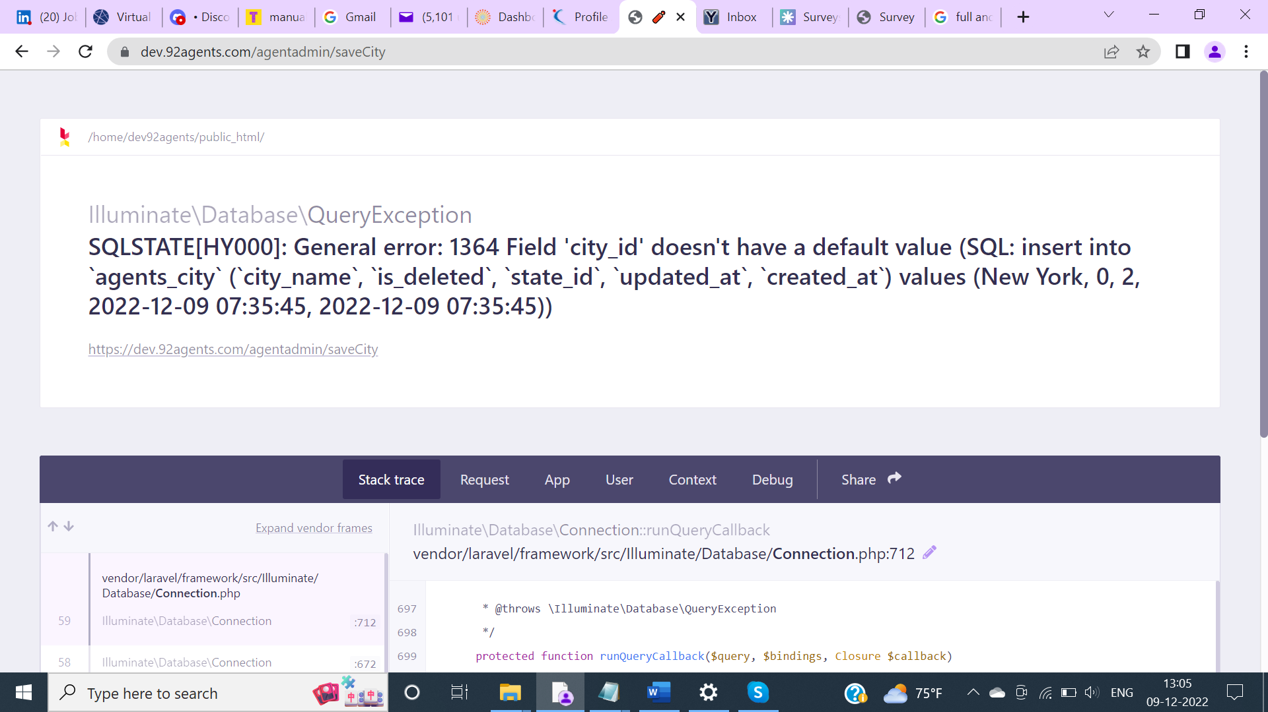

***Issue Type: Functional***

***Severity : Major***

1. Login to Admin Panel.
2. On the Dashboard page, click on More Info appearing in the Total State.
3. Try to add new State.

Actual: Exception occurs when trying to add a new State.

Expected: The user should be able to add new State successfully.

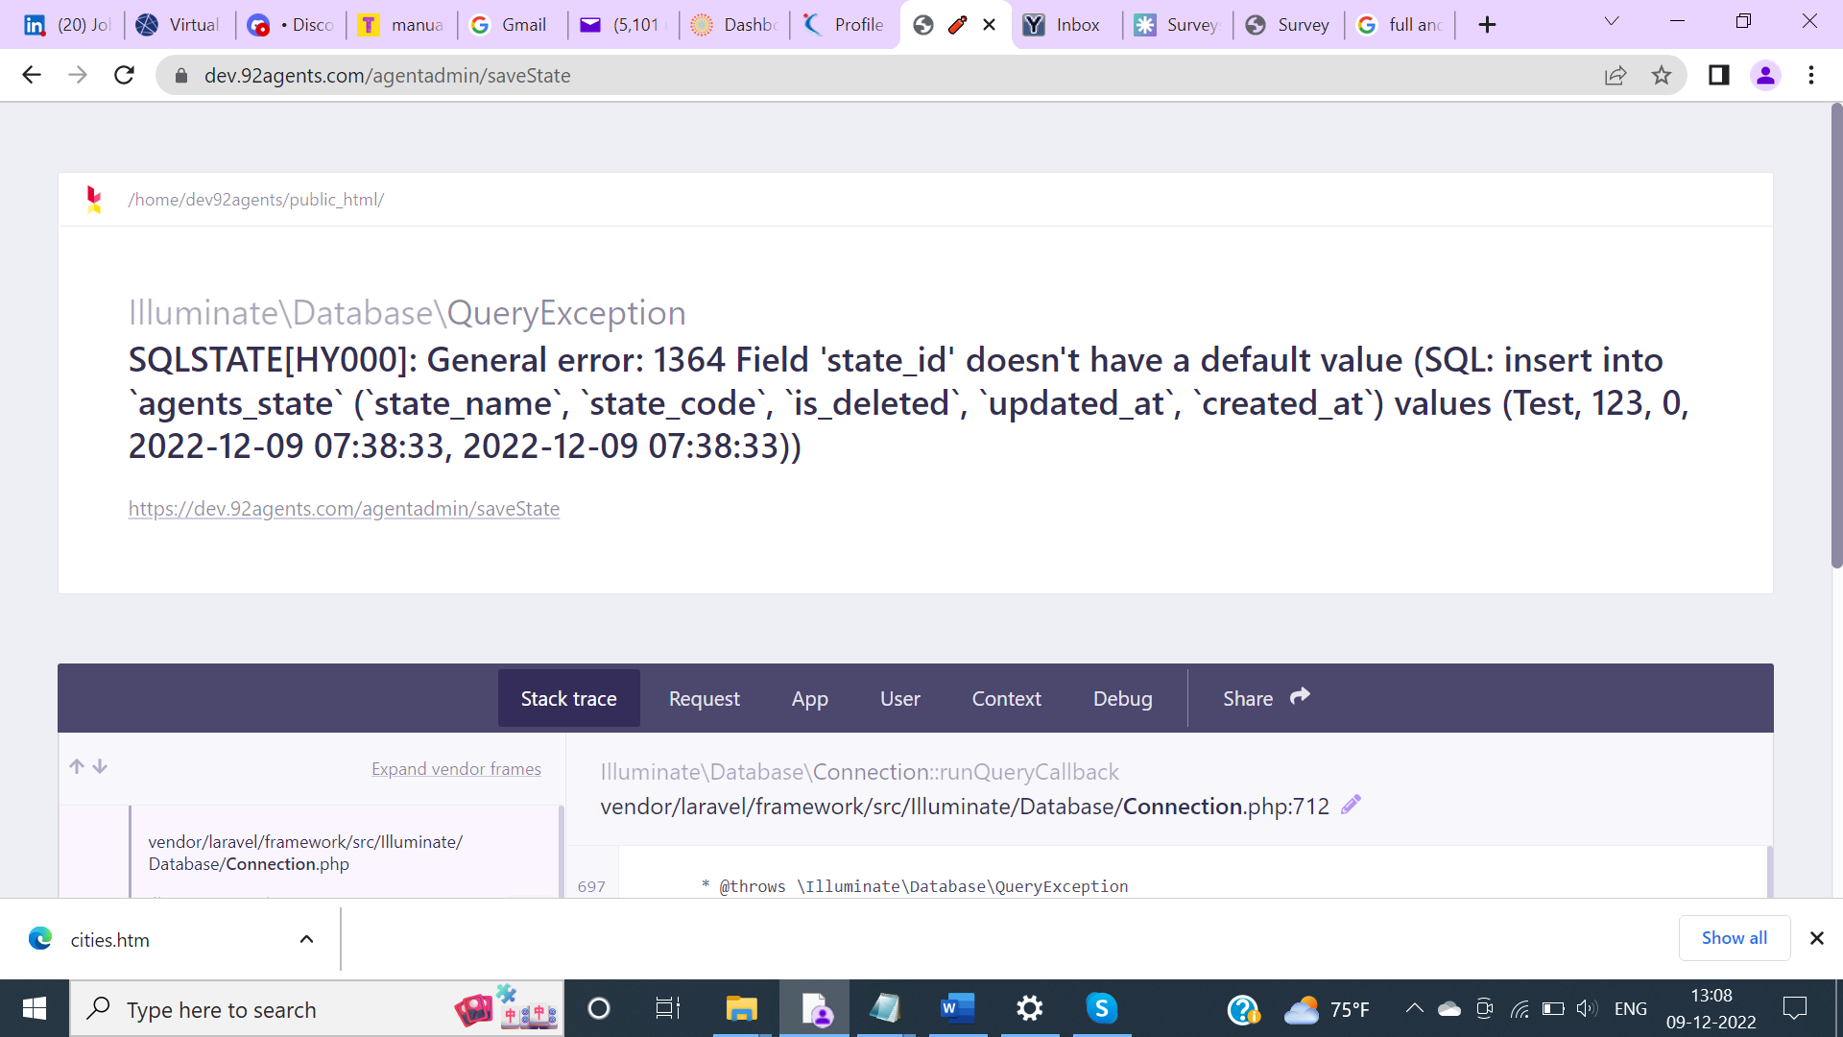

***Issue Type: UI***

***Severity : Major***

1. Login to Admin Panel.
2. On the Main Navigation, observe the ‘Skills/Specialization’ menu label.

Actual: Single quote appears Skills/Specialization menu label.

1. Expected: Menu label should appear as Skills/Specialization.

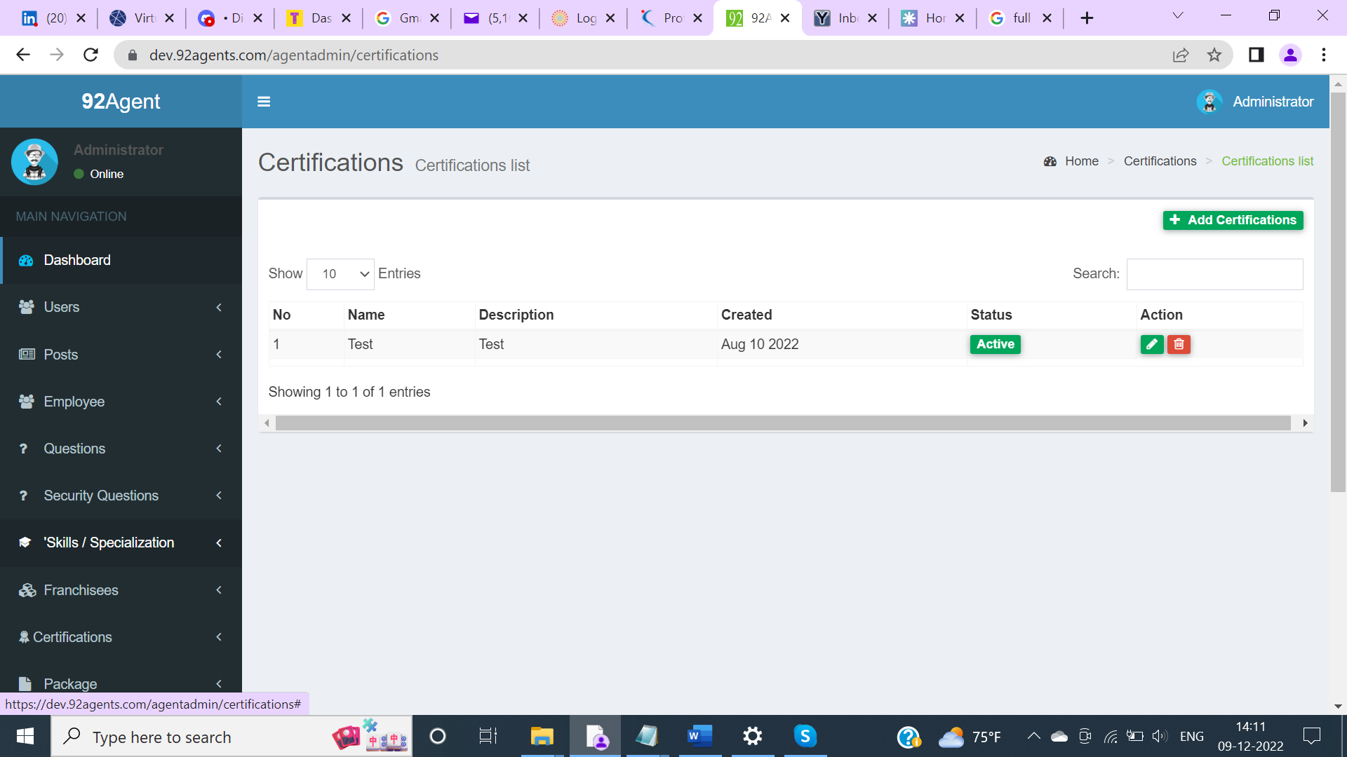

***Issue Type: UX***

***Severity : Major***

1. Login to Admin Panel.
2. On the Main Navigation click on any sub-menu item say ‘Add Question’ appearing under the ‘Questions’ menu.

Actual: Add Question sub-menu is getting collapsed and is not visible.

Expected: Add Question sub-menu should be visible so that User can know the clicked sub-menu.

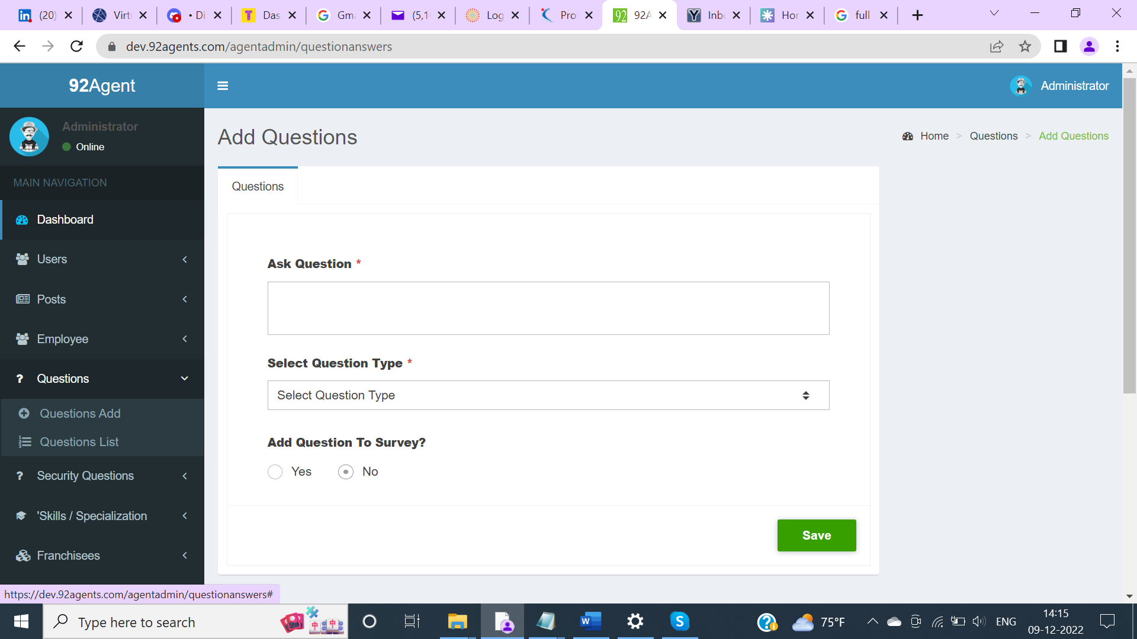

***Issue Type: UX***

***Severity : Major***

1. Login to Admin Panel.
2. On the Main Navigation click on the sub-menu item ‘Agents’ appearing under the ‘Users’ menu.

Actual: Navigation controls Previous and Next appear when there is no data.

Expected: Navigation controls Previous and Next should not appear when there is no data. When there is no data on Seller/Buyer list page, navigation controls ( pagination) does not appear.

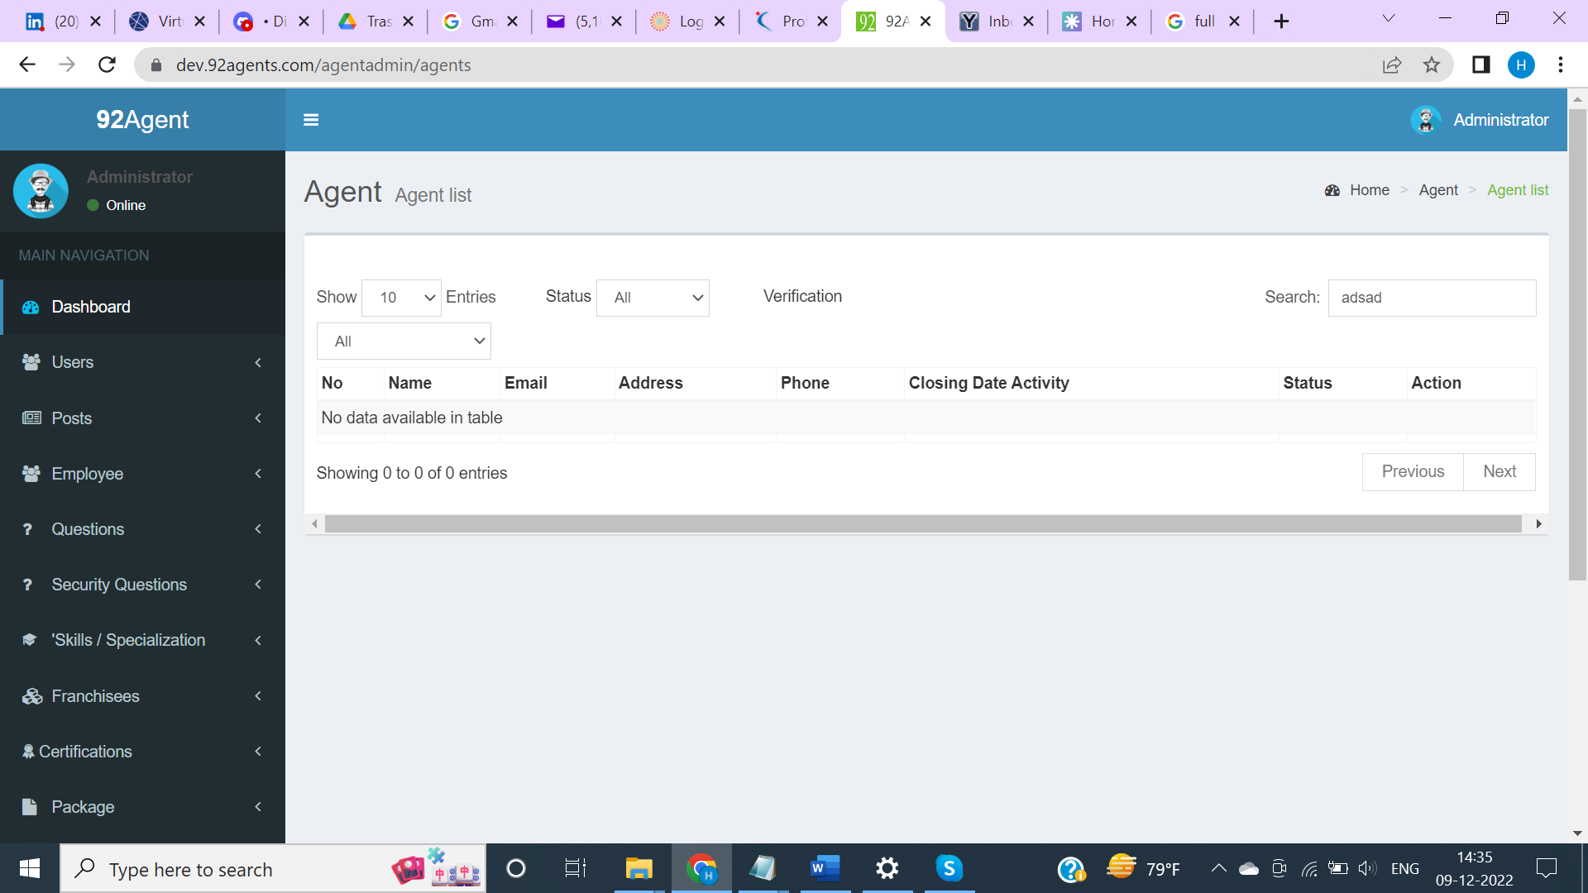

Seller/Buyer List

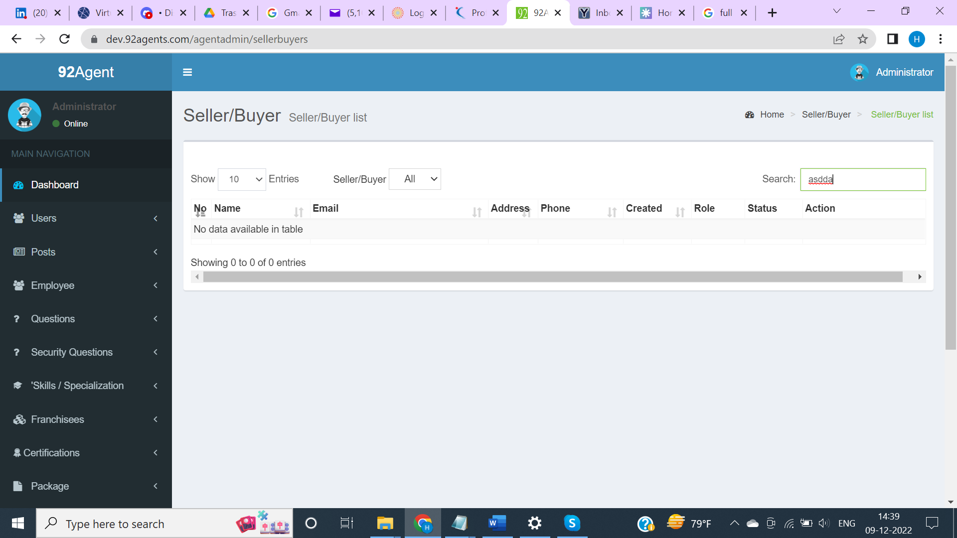

***Issue Type: UX***

***Severity : Major***

1. Login to Admin Panel.
2. On the Main Navigation click on the menu ‘Questions’

Actual: Sub Menu label appears as ‘Questions Add’

Expected: Sub Menu label should appear as ‘Add Questions’ instead of ‘Questions Add’. For few Sub menu items text appears as ‘Add Franchisees’ , ‘ Ad Certifications’.. etc.

